Internet Safety and Netiquette Training Module Notes

Below are the 5 categories, a description of each concept and sample explanations containing the material being tested.

Category 1: What is Cyberbullying?
Concept: Cyberbullies use technology to post mean and hurtful information
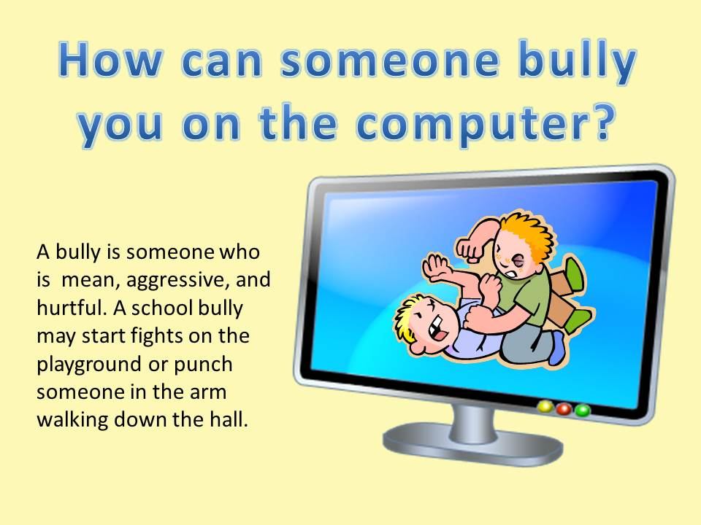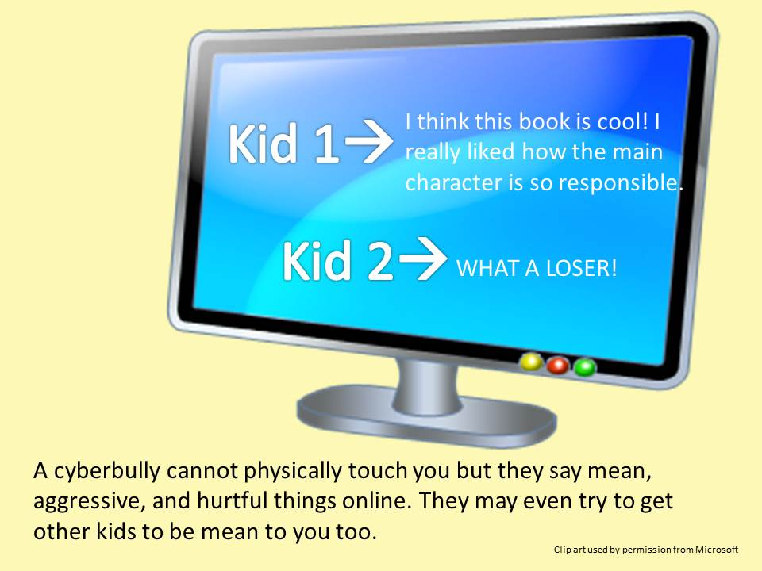

Category 2: Stopping Cyberbullying
Concept: Properly responding by 1.ignoring, 2. Asking to stop, 3. Report to adult/website, 4. Collect evidence, and don’t join in, and 5. Report if you witness cyberbullying of someone else.

Category 3: Netiquette
Concept: Etiquette or good manners and appropriate behavior online; Be kind, friendly, respectful; Add to the conversation, don’t just agree and repeat; text features have meaning (all caps, italics, bold, emoticons); word choice affects tone/meaning; avoid text speak
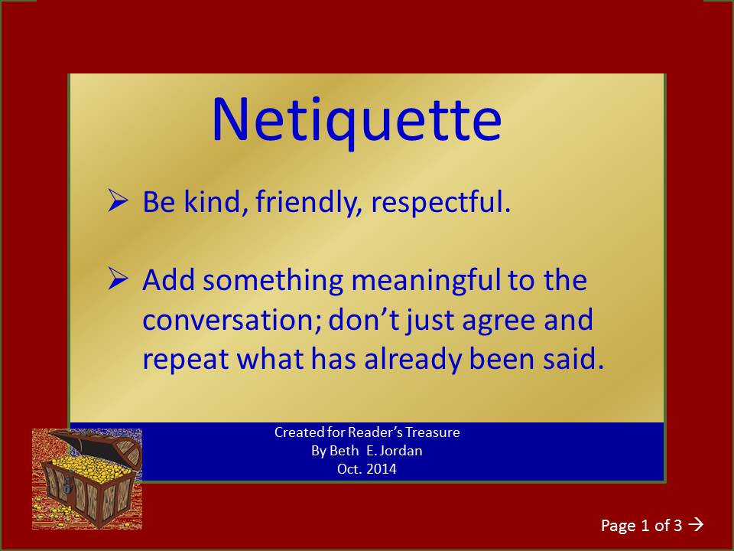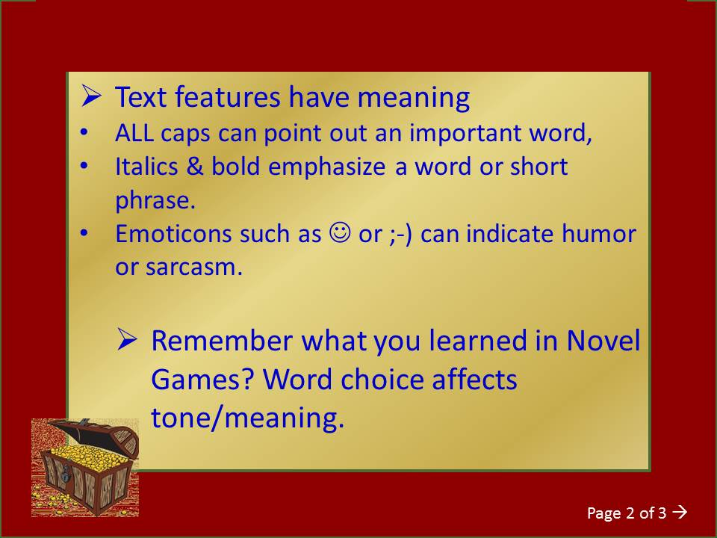
Avoid using all caps, it means you are yelling. It's okay to use all caps to emphasize just one word like REALLY or VERY. Use italics, bold, or underline for emphasis.

Using only lower lowercase letters and text speak like LOL is okay when texting with friends, but not in a serious talk about a topic. Not everyone will know what you mean. Also, use proper capitalization, punctuation, and spelling.

A meaningful subject line lets others quickly see what your post is about and helps them find it again later. It should convey your main idea in a short phrase.

Always add to the conversation. Don’t just say “I agree”. In person, you may nod your head and say “really? Uh-huh” to show the person you are listening, but it doesn’t have the same effect online. Get to the point and stay on topic.
~ ~ ~ ~ ~
There are several ways to add emphasis and convey tone in your words. Use italics, bold, and underline to emphasize words or phrases. Emoticons, or smilies, can be helpful. For example, a winky face can let the readers know you are using humor. It’s hard to pick up on that when you can’t see facial expressions. Be careful, though. Too many of them will just be distracting and not really add to the message. Instead you could use specific vocabulary and precise adjectives.
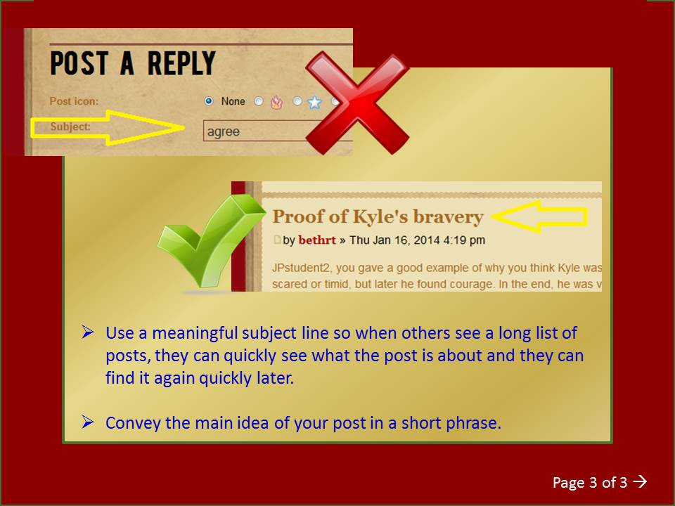

Category 4: Internet Privacy
Concept: what is personal information, what can and cannot be shared to protect you from strangers who could use the info to harm you
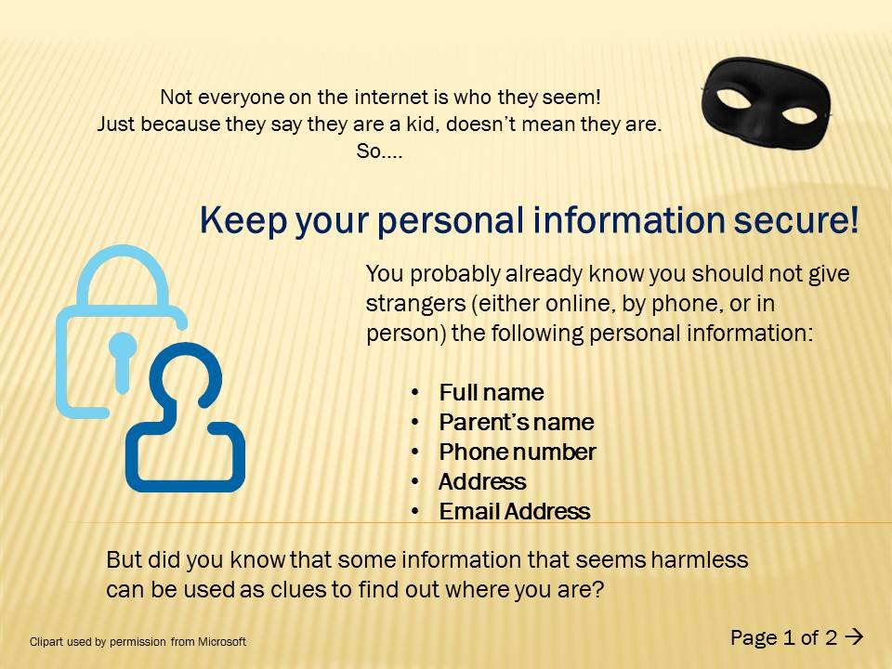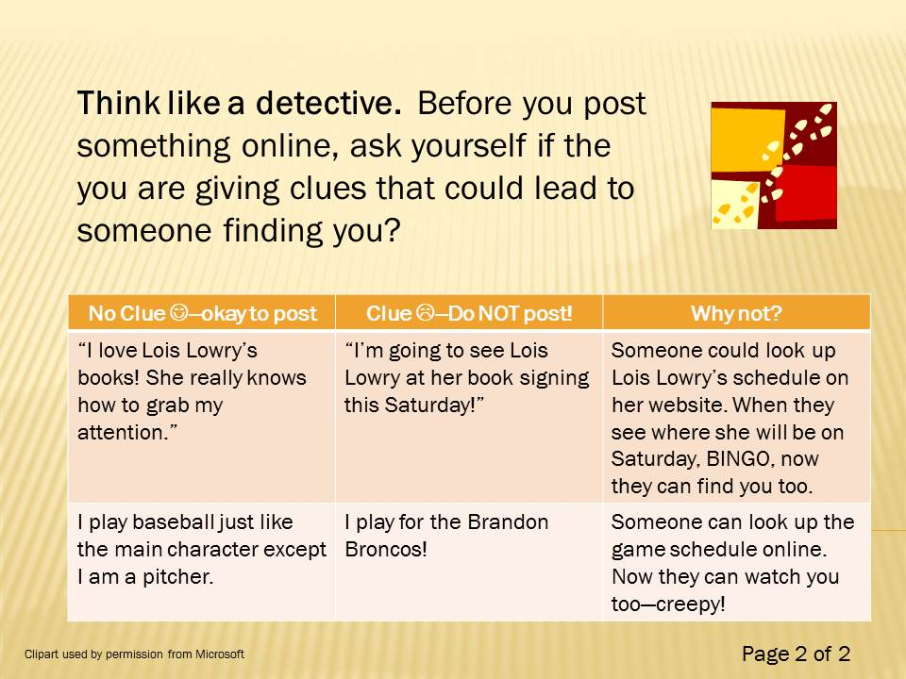

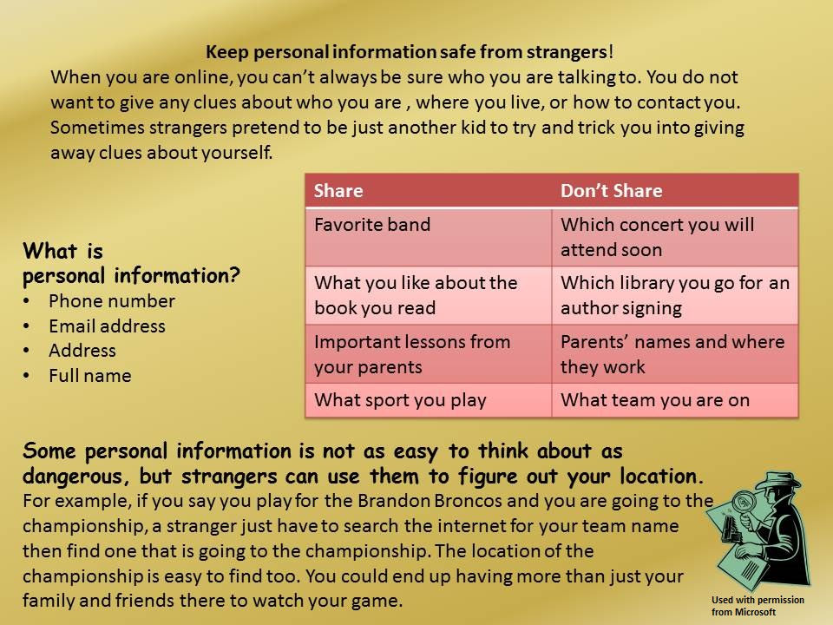
Category 5: Safe Usage
Concept: Never share private/identifiable information; never meet someone in person; make sure your parents know you are online; only go to sites that an adult has approved

